**Implement a Timer**

**LAB 08**



**Spring 2022 CSE307L MBSD Lab**

Submitted by: **Ashfaq Ahmad** Registration No. : **19pwcse1795** Class Section: **B**

Student Signature:

Submitted to: **Prof: Aber Irfan sab** August 02, 2022

# Department of Computer Systems Engineering University of Engineering and Technology, Peshawar

**Task 1:**

Write a program to generate 1 KHz signal with 75% duty cycle.

## Code:

#include <reg51.h> #include <stdio.h>

sbit Led = P2^0;

void timer() interrupt 1

{

if(Led)

{

TH0 = 0xFF; //250 usec delay TL0 = 0x05;

}

else

{

TH0 = 0xFD;

TL0 = 0x11;

}

Led = ~Led;

}

void init()

{

TMOD = 0x1; EA = 1;

ET0 = 1;

TH0 = 0xFD; //750 usec delay TL0 = 0x11;

}

void main(void)

{

init(); TR0 = 1;

while (1)

;

}

## Output / Graphs / Plots / Results:

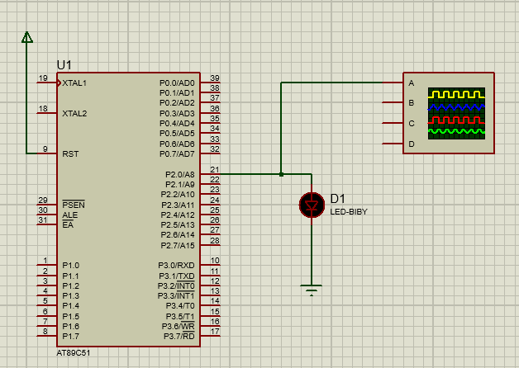**Schematic:**

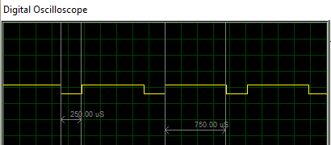**Oscilloscope Verification:**

# Task 2:

Write a program to generate 500 Hz signal with 30% duty cycle.

## Code:

#include <reg51.h> #include <stdio.h>

sbit Led = P2^0;

void timer() interrupt 1

{

if(Led)

{

TH0 = 0xFA; //1400 usec delay TL0 = 0x87;

}

else

{

TH0 = 0xFD;

TL0 = 0xA7;

}

Led = ~Led;

}

void init()

{

TMOD = 0x1; EA = 1;

ET0 = 1;

TH0 = 0xFD; //600 usec delay TL0 = 0xA7;

}

void main(void)

{

init(); TR0 = 1;

while (1)

;

}

## Output / Graphs / Plots / Results:

**Schematic:**

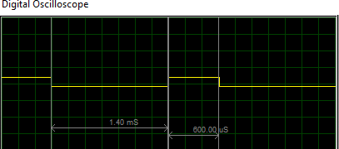**Oscilloscope Verification:**